ISQA 4900

Activity 2

Malika Salikhova

<https://github.com/msalikhova/ISQA4900.git>

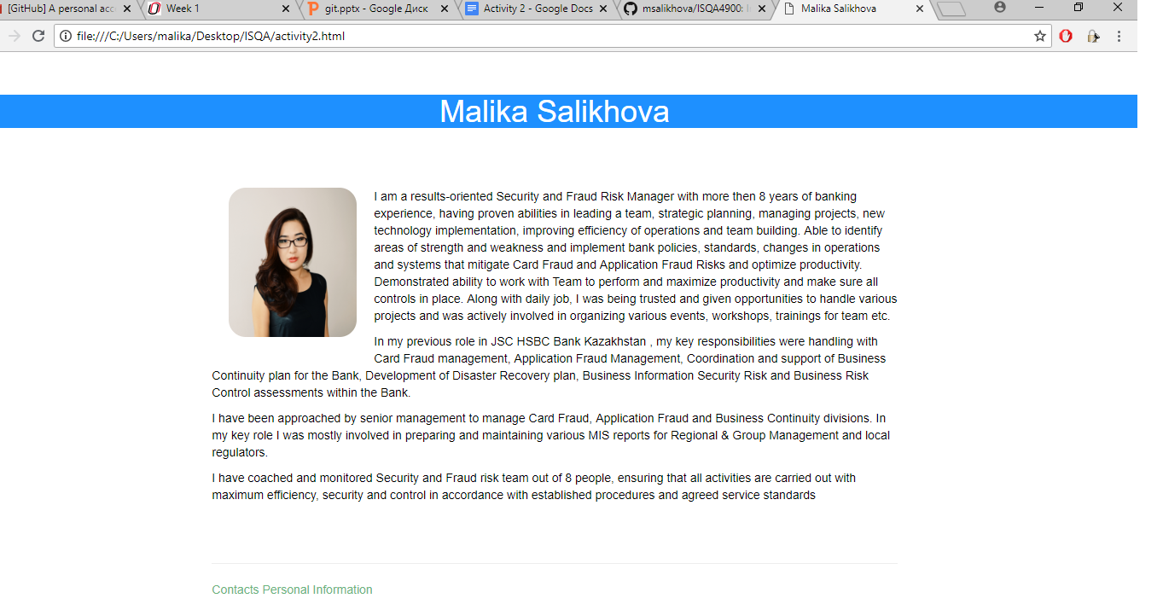



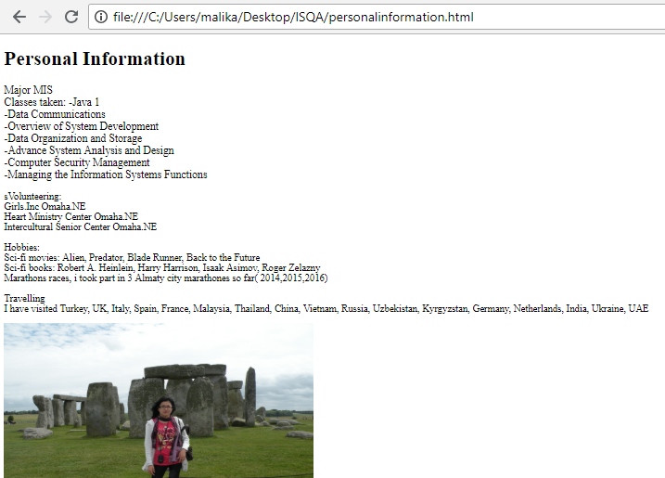

Questions

1. What is the value of having a CSS in one page HTML in other pages? Why not simply embed the CSS in each web page?

A separate CSS file allows us to make the process of programming more structured and effective. Its makes the programming code easier to use because we know exactly where the required piece of code is if we want to fix a specific part of web page. If we will put the CSS in each web page we’ll be forded to make changes in each page separately that is time consuming and brings additional troubles to programmer if there are numerous pages.

1. There are many cloud based document replication facilities such as DropBox, Box, Microsoft OneDrive. What is the advantage of using a tool like Git and GitHub over simply using something like Box to manage code?

From my point of view, the main advantage of Git and GitHub is that it can track all changes, the history of changes, who made changes and when. As I understood it also keeps the copy of code with all changes on local machine, so in case of disaster there is always a backup copy.